Plastic Pollution and Seabird Workshop (Beyond the Fulmar…)
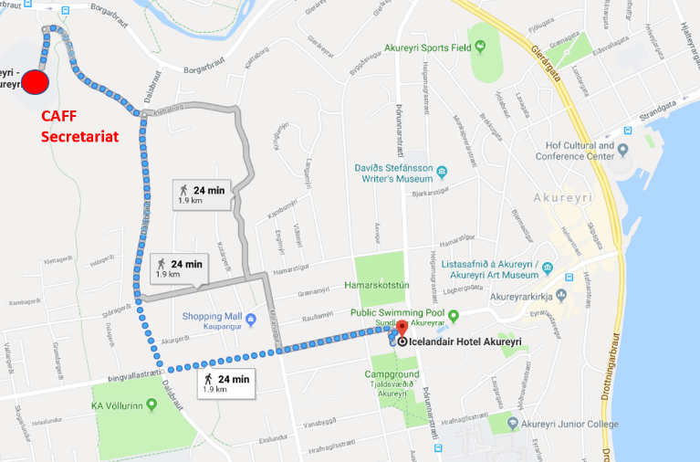
Location: The workshop will take place at the Research building of the University of Akureyri. The building the CAFF secretariat is located in.
Date: Monday March 25, 2019
Background: Plastic pollution is a growing concern throughout the globe, and in the Arctic. To date the only legislated monitoring program of plastics pollution is found in the North Sea and uses the Northern Fulmar (van Franeker et al. 2011). The use of this standardized tool in several regions within the Northern Hemisphere has lead to a better understanding of plastic pollution trends (Provencher et al. 2017).
There have been reports on plastic ingestion in seabirds from the Arctic dating back to the 1980s (Day 1980; Robards et al. 1995), and recent work has shown that plastic pollution is now pervasive in several Arctic seabird species (Provencher et al. 2014; O’Hanlon et al. 2017). These studies have assessed the current state of knowledge of plastics in seabirds, and regional frameworks for monitoring plastics via seabirds have been proposed (Provencher et al. 2015; O’Hanlon et al. 2017), but there still lacks a coordinated monitoring framework for plastic-seabird interactions (ingestion and entanglement) across the Arctic.
Objective: This workshop aims to develop a strategy for collecting information on seabird and plastic interactions (ingestion and entanglement) throughout the Arctic over the next 3-5 years with a focus on 2-4 species that can be collected throughout several regions. Ultimately, this data will then inform an assessment of seabird-plastic interactions that will have data that is comparable across regions to assess spatial patterns. Long term, the focal species selected should be species for collections are possible into the foreseeable future, so that temporal data on plastic pollution may be collected.
Other related objectives may include:
- Assess plastic ingestion in species that have not been assessed to date in some regions, and may be vulnerable to plastic ingestion and accumulation; and
- Assess the impacts of plastic on colonies via nest entanglement.

Agenda
Time | Item | Lead
9:00 | Welcome to Akureyri | Tom Barry (CAFF)
9:15 | Overview of the findings of the PAME: Desktop Study on Marine Litter including Micro-plastics in the Arctic | PAME Secretariat
9:30-9:40 | Background to the Project | Tom Barry (CAFF)
9:40 | Outline of the meeting:  - Objectives  - Products expected from the project and the meeting | Mark Mallory & Flemming Merkel
10:00 | National reports (5-10 minutes each)  - Canada  - Greenland - Kingdom of Denmark  - Finland  - Iceland  - Norway  - Russia  - Sweden  - USA  Each presentation should address the following questions:  - Current monitoring programs for plastics and seabirds? Either planned or opportunistic?  - What species have been examined?  - Is the focus on ingestion or entanglement? Or both?  - What species they are considering for focal species that could be focused on? | Various speakers
1130 | Discussion of standardized sampling and reporting techniques  - Pellets, carcasses, regurgitations, nest incorporation  - Size classes  - Sorting and reporting  Short inclusion of the other work that can stem from this type of standard monitoring  - Trophic transfer, highlight Sjur’s study in the Faroes  - Contaminant transfer, the recent work from PLI on the UV Stabilizers and Phthalates  - Seabirds as concentrators of plastics, the plastics in poop work leading to the environmental sampling around the colonies in Qik in 2018 | Mark Mallory(supported by Jenn Provencher)
1200 | Lunch – will this be provided?
1300 | Round Table discussions:  Three tables that people would move through and answer these questions on poster paper in small groups. 10 minute at each table  - What are the most pressing questions we want to address relating to seabird-plastics interactions?  - What are the species that people have access to, and can easily study or get samples in relation to plastics questions over the next 3-5 years (i.e. hunted or harvested samples, carcasses, pellets, regurgitations, tissues, guano)?  - What data exists for different regions on seabird-plastic interactions that we can build on?  In new groups of 3-5 people, given people 20 minutes to circulate around the posters from the previous session, and then work together to draft what they think would be a good framework for plastic monitoring in seabirds that would include:  - 2-4 species  - Sample type needed for each species  - Identify what component of the ecosystem the species are sampling  - Identify what countries/locations could contribute
1500 | Coffee
1530 | Presentations of the group proposed frameworks to the other groups with questions and discussions
1700 | Wrap for the day = all issues resolved

Workshop products:
- The discussions, poster notes, and the presentations will then be used by Jenn, Mark, Flemming, Jannie, and Julia to draft the framework.

