The Arctic Migratory Birds Initiative (AMBI)
28 November 2013

Initiative: | The Arctic Migratory Birds Initiative (AMBI): Protecting arctic lifestyles and people through migratory bird conservation
Country Leads | Canada, Norway, Russia
Start Date: | December 2013 | Completion Date: | Interim results 2015; ongoing

Project Goal:
To improve the status and secure the long-term sustainability of declining Arctic breeding migratory bird populations.

Project Summary:
- The project is envisioned as having three steps (Figure 1). During the first step, species or groups of species or habitats will be prioritized based on the urgency of the conservation need or the benefits to multiple species.
- During the second step, the state of knowledge for priority species or habitats will be assessed. The following questions will be posed:
- Do we know the most important habitats and locations for each part of the species’ annual cycle?
- Do we understand the main cause(s) of decline for this species or the conditions necessary to maintain or recover populations?
- Can we identify the conservation actions that need to be undertaken to stabilize or reverse declines, or to maintain current population levels?
- During the third step, direct actions to improve the conservation status of priority species will be identified. Identified actions could be concrete conservation measures or they could be studies to gather information crucial to identify appropriate measures. Where the state of knowledge is sufficient, the project will identify necessary conservation actions (for example; habitat securement, improved harvest regulations, sustainable development) and broker agreements to implement actions. Where the state of knowledge for a priority species is poor, conservation action and work to obtain necessary information will proceed simultaneously, where possible.

This project will require enhanced cooperation among Arctic countries, as well as cooperation between Arctic countries and countries outside the Arctic, that host Arctic birds during the non-breeding season.
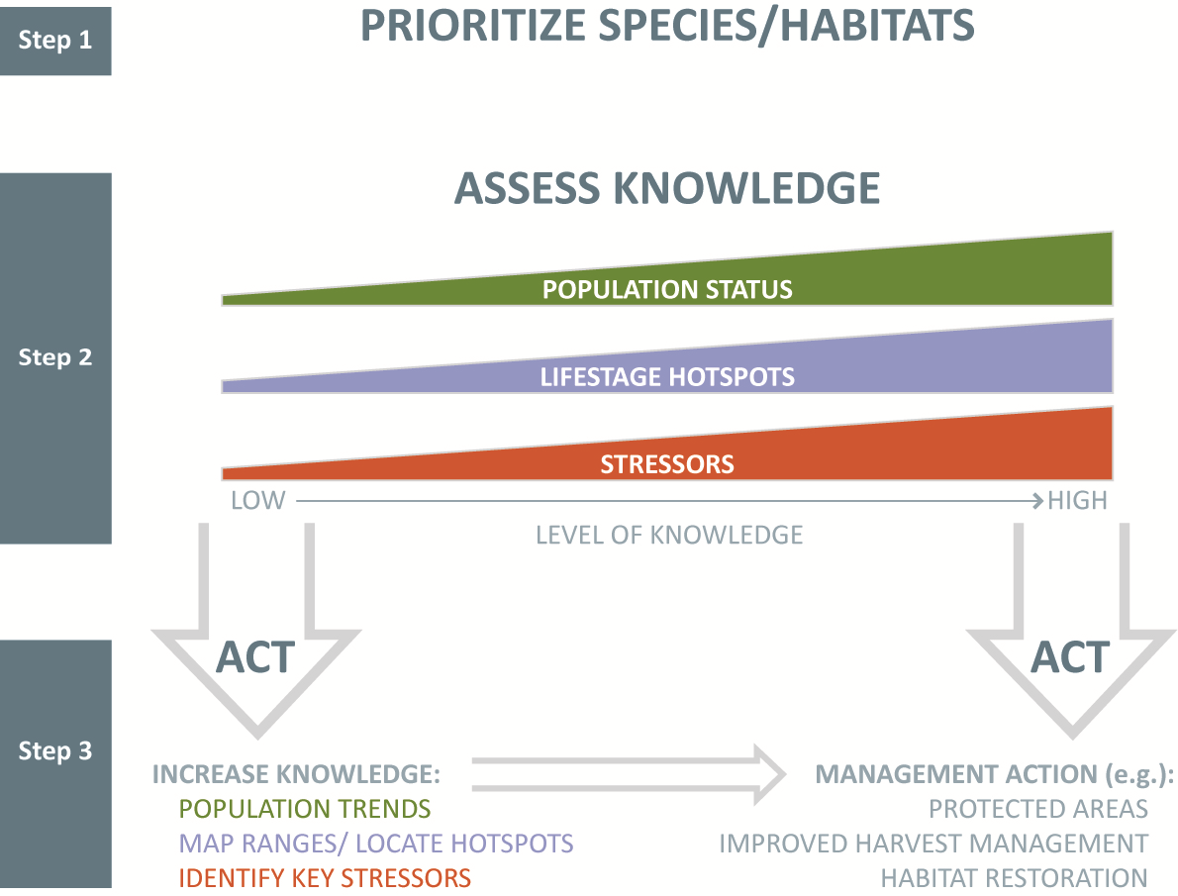
Figure 1: Summary of project steps. Step 1 will prioritize species and habitats based on conservation risk and benefits to multiple species; Step 2 will assess the status of knowledge; Step 3 will result in direct actions where the state of knowledge is high, and fill important gaps in knowledge where the state of knowledge is poor. Implementation of effective management actions for priority species and habitats is the goal.
Actions | Proposed Target Completion
1. Priority list of Arctic breeding migratory birds or habitats | January 2014
2. AMBI implementation meeting, Montreal | February 2014
2. Assessment of state of knowledge for top priority species or groups of species or habitats | June 2014
3. Actions identified for highest priority species or species groups (including schedule of studies where further information is required) | October 2014
4. Biodiversity symposium | November 2014
5. Commitments secured to implement actions for high priority species or habitats where knowledge is sufficient | May 2015
6. Status Report to Ministers | June 2015

Organizing Structure
The project co-leads (Canada, Norway, Russia), the CAFF chair, and the CAFF Executive Secretary will participate in the steering committee for the initiative. The Steering Committee is responsible for the overall coordination and implementation of the project. Membership on the steering committee is open to other CAFF management board members who request a seat on the committee. The co-leads will invite Permanent Participants to participate on the Steering Committee. It is important that the indigenous viewpoint is incorporated into this project, particularly the priority-setting and knowledge assessment portions. BirdLife International will be invited to become an expert advisor to the Steering Committee.
The initiative’s focus is on Arctic seabirds and shorebirds and habitats. However, species or habitats from other bird groups may also be identified as priorities.
Organization at the sub-steering committee level will vary by geographic region, and by species group. In many cases, Arctic seabirds tend to spend their entire life cycle in the arctic, or in adjacent regions. For these species, Arctic Council countries and PPs will be the primary entities involved in seabird research and conservation actions. There are a few species (e.g. Arctic Tern) whose annual cycle takes them far from the Arctic. In those cases non-arctic countries will need to be involved. The existing CAFF expert group CBird is already well organized to undertake prioritization, knowledge assessment, and to identify conservation actions. CBird may bring in other technical experts as required.
Circumpolar shorebirds, on the other hand, are shared by countries all over the globe. Research and conservation action cannot be undertaken solely by Arctic Council countries. Moreover, no group like CBird exists for shorebirds.
For shorebirds, Step 1 (prioritizing species and habitats) will likely be undertaken by subject matter experts from circumpolar countries. Assessing state of knowledge and identifying conservation actions will likely and include experts from parts of the non-breeding range of species.

Approach
- Prioritization
Prioritization criteria will address:
- percentage of species breeding range that is in the Arctic
- rate of population decline or habitat loss
- vulnerability to catastrophic events (due, for example, to small range or migration bottlenecks)
- threat to key habitats (inside and outside the arctic)
- importance to Arctic indigenous peoples

Results will be grouped in categories: i.e. ‘very high priority’; ‘high priority’; ‘medium priority’; and ‘not a priority’. Early conservation actions will concentrate on the species or habitats in the ‘very high priority’ category.

- Assessing the State of Knowledge
State of knowledge will be assessed in the first instance for species and habitats in the ‘very high priority’ and ‘high priority’ categories. Local indigenous knowledge about changes in species and habitat abundance, distribution, and stressors will be incorporated into the assessment where appropriate. For some species, state of knowledge is high. For example, based on solid knowledge and scientific evidence (1), the CAFF board identified the key stressors (inter-tidal land reclamation and unsustainable harvest in intertidal habitats in Southeast Asia) that have led to serious declines in a number of bird species that breed in the Russian and Alaskan Arctic. For these species meaningful action is urgent and an assessment of the state of knowledge is virtually complete.

For other species, rapid declines are known but the causes/locations of declines are not (e.g. some seabirds that overwinter in the North) or declines are suspected but not well documented. For these species critical knowledge gaps will have to be filled before appropriate actions can be identified. New technologies, such as geo-locators, will be used to track birds along migratory routes and identify hot spots. On-the-ground observations and surveys, using partner organizations, will allow the documentation of threats.

Subject matter expert groups will be struck for species, groups of species, or habitats to assess the state of knowledge; to identify conservation actions to increase populations and habitat functionality; or to identify knowledge gaps that need to be filled before conservation action can be determined.

- Acting
Where knowledge is high early actions can be developed. Appendix 1 describes the situation for certain Arctic species using the East Asian-Australasian flyway. It provides a case study where priority is very high, causes and locations of declines are known, and mitigating conservation actions are known and will benefit a suite of species. For species with migrations routes outside the Arctic, international cooperation will be important. New and existing conservation measures, including binding instruments, will be considered. This will likely involve Arctic countries, observer countries and organizations, old and new partnerships and existing and new mechanisms. Actions will be varied and likely multi-pronged. For example, habitat securement, improved harvesting regulations and more sustainable development could all play a role, depending on the situation.
Criteria for immediate conservation action will be: biological need (prioritization exercise) and readiness to act (assessment exercise). In some cases ‘acting’ may include facilitating directed research into causes of declines, where the priority is very high but the state of knowledge is insufficient. In either instance, the steering committee will look for commonalities among priority species or habitats, by stressor, or by research need. Species or habitats will then be grouped by commonality, to make it easier for the steering committee to identify conservation actions that will deliver the greatest benefit for effort.

1. MacKinnon, J., Verkuil, Y.I. & Murray, N. 2012. IUCN situation analysis on East and Southeast Asian
intertidal habitats, with particular reference to the Yellow Sea (including the Bohai Sea). Occasional Paper of
the IUCN Species Survival Commission No. 47. IUCN, Gland, Switzerland and Cambridge, UK. ii + 70 pp.

Background

Arctic-breeding birds use as many as eight different flyways to move from Arctic breeding grounds to overwintering or stopover sites at lower latitudes. Many of these bird populations are declining at an unprecedented rate for variety of reasons: destruction of coastal wetlands for land reclamation and drainage, habitat degradation, trapping/poaching, unsustainable harvesting and climate change. A memorandum to the Chair of Senior Arctic Officials, October 6, 2012, highlighted the plight of migratory Arctic breeding birds, especially those along the East-Asian Australasian flyway.
Migratory birds are an important indicator of ecosystem health. In the Arctic, seabirds can indicate much about the health of the oceans, where the majority of marine life is out-of-sight. Shorebirds – despite the name – occur throughout Arctic habitats and are also an important indicator of change.
Birds are harvested by many people on Arctic breeding grounds, along migratory routes, and on overwintering grounds. Seabirds, for example, are taken for their meat, eggs and down in all Arctic countries. In Alaska, Canada, Greenland, and Russia more extensive harvest rights are given to indigenous people, in recognition that subsistence harvest of seabirds is essential to maintaining a traditional lifestyle. The annual take of seabirds is significant, ranging from about 4,000 in Norway to 260,000 in Canada. Traditional harvest of seabird eggs is known to be in the tens of thousands in Canada and unknown quantities in other countries.
Shorebirds and seabirds contribute to economic diversification in Arctic communities through small scale ecotourism activities which are low impact, independent of development cycles, and more compatible with land-based pursuits. For example, each May, the Copper River Delta Shorebird Festival brings visitors and economic stimulation to the community of Homer, Alaska.
CAFF has devoted a significant amount of attention to migratory bird issues in the past (Appendix 2). AMBI will benefit greatly from these past studies and assessments.

Appendix 1. Russian and Alaskan Shorebirds on the East Asian -Australasian Flyway
The rapid decline of Arctic breeding shorebirds using the East-Asian flyway is well known, and threats and the required restorative actions are understood. Key affected species include (but are not limited to) Spoon-billed Sandpiper and Nordman’s Greenshank (both IUCN Critically Endangered), and Bar-tailed Godwit, Great and Red Knot and Grey-tailed Tattler (IUCN near threatened). Intertidal areas in Southeast Asia are the key endangered habitats where Arctic migrants spend three quarters of their annual cycle. Inter-tidal land reclamation and unsustainable harvest are the key stressors that need to be addressed. There was consensus around this issue at the CAFF Board Meeting in Yellowknife, Canada in September 2013. CAFF recently signed a Resolution of Cooperation with the East Asian Australasian Flyway Partnership (EAAFP).

Key objectives would be to secure agreements and develop joint actions, including the development and implementation of conservation strategies and management plans with Arctic Council observer countries of the Flyway (China, Korea, Japan, Singapore and India) as well as other key Southeast Asian countries. Actions could include the reduction of harvest to a sustainable level, and securement (or restoration) of a portion of each countries’ intertidal habitats to functioning ecosystems, to ensure its continued availability for wintering populations of arctic migrants. Activities on the Arctic breeding grounds of the Flyway (tundra habitats in Russia and Alaska) will be coordinated with actions on the non-breeding grounds in the countries mentioned above. Implementation of IUCN Resolution N28 (adopted by governments of Arctic and mentioning Asian countries in Jeju, South Korea during the September 2012 World Conservation Congress) on conservation of intertidal wetlands of East Asia could also form part of this project.

Appendix 2: Previous CAFF work that has informed AMBI

Arctic Biodiversity Assessment: Report for Policy Makers (2013) – Download here

Arctic Biodiversity Assessment- Status and trends in Arctic biodiversity (2013) – Download here

Arctic Biodiversity Assessment - Status and trends in Arctic biodiversity: Synthesis (2013) - Download here

Arctic Biodiversity Assessment (2013) Chapter 4, Birds – Download here

CAFF Monitoring Series report No.8 (2013) Arctic Terrestrial Biodiversity Monitoring Plan – Download here

CAFF Assessment Series No.8 (2012) Arctic Species Trend Index: Tracking trends in Arctic vertebrate populations through space and time – Download here

CAFF Monitoring Series No.7 (2012) Arctic Freshwater Biodiversity Monitoring Plan – Download here

CAFF Monitoring Series No.3 (2011) Arctic Marine Biodiversity Monitoring Plan – Download here

CAFF Assessment Series report No.1 (2011) Arctic Seabirds Breeding in the African-Eurasian Waterbird Agreement (AEWA) Area: Status and Trends – Download here

Arctic Biodiversity Trends 2010: selected indicators of change. Seabird indicators #4, #10, #19

CAFF Strategy Series (2011) Seabird Information Network: Concept Paper – Download here

CAFF Technical repot No.16 (2008) CBird: Seabird harvest in the Arctic – Download here

CAFF CBMP Report No.12 (2008) A Strategy for Developing Indices and Indicators to Track Status and Trends in Arctic Biodiversity – Download here

CAFF Monitoring report No.15 (2008) Framework for a circumpolar seabird monitoring framework – Download here

CAFF Technical report No.18 (2008) International Ivory Gull Conservation Strategy and Action Plan – Download here

CAFF Report (2004) Global Flyway Scale Monitoring and Conservation Programs for Migratory Waterbirds of the Arctic – Download here

CAFF (2004) Cooperative Strategy for the Conservation of Biological Diversity – Download here

CAFF workshop report (2000) Conservation of Migratory Arctic Birds – Download here

CAFF Technical report No.4 (1998) Global Overview of the Conservation of Migratory Arctic Breeding Birds outside the Arctic – Download here

CAFF CBird report (1997) Circumpolar Eider Conservation Strategy and Action Plan – Download here

CAFF CBird report (1996) International Murre Conservation Strategy and Action Plan – Download here

CAFF CBMP Report No.4 (2004) CHASM, 2004. Shorebirds Expert Network Monitoring Plan. Monitoring Arctic nestingShorebirds: An International Vision for the Future – Download here

